Asia-China Hollow Handle Spade Money, type 2 Sloping Shoulder

空首布卢氏, , Kōng shǒu bù lú shì, Lushi in western Henan, 400-300 BCE.

The two outside lines on the obverse and reverse are at an angle , The central line is often missing as in this example. The inscriptions are clear and usually consist of two characters. Associated with the Kingdom of Zhou and the Henan area. Harthill 2.166, rarity 3. FD 97.

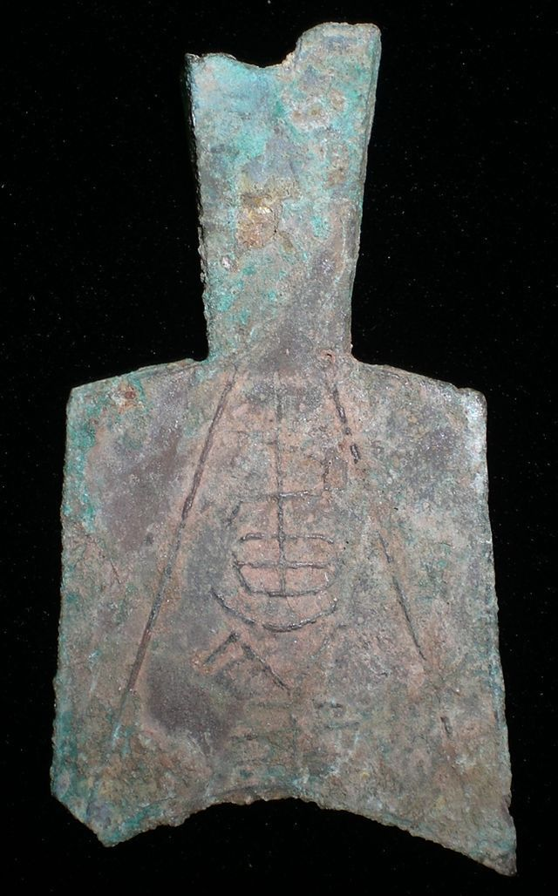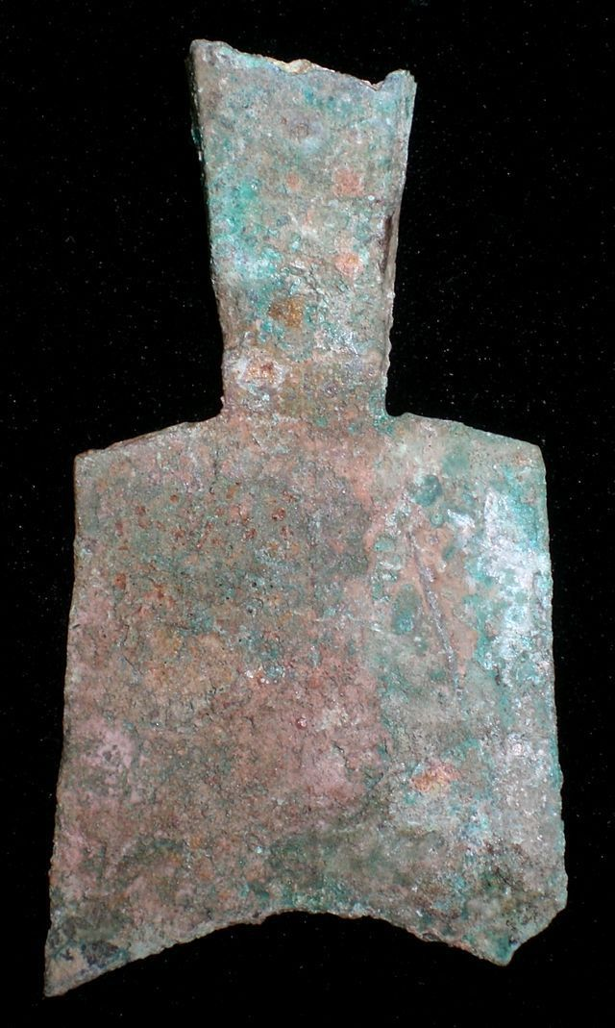

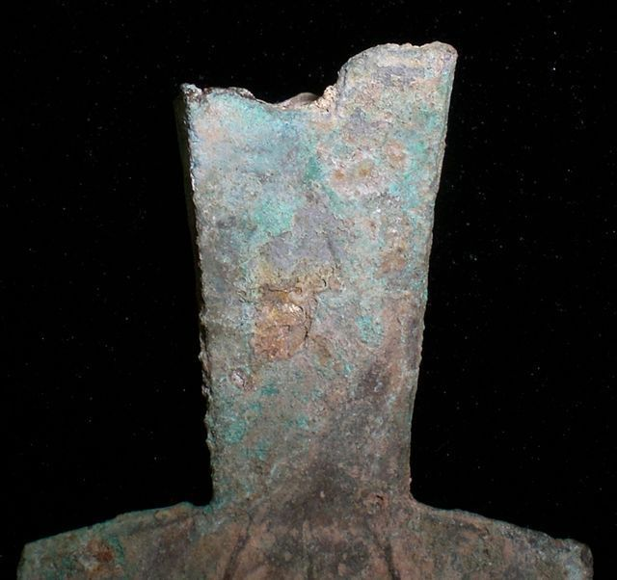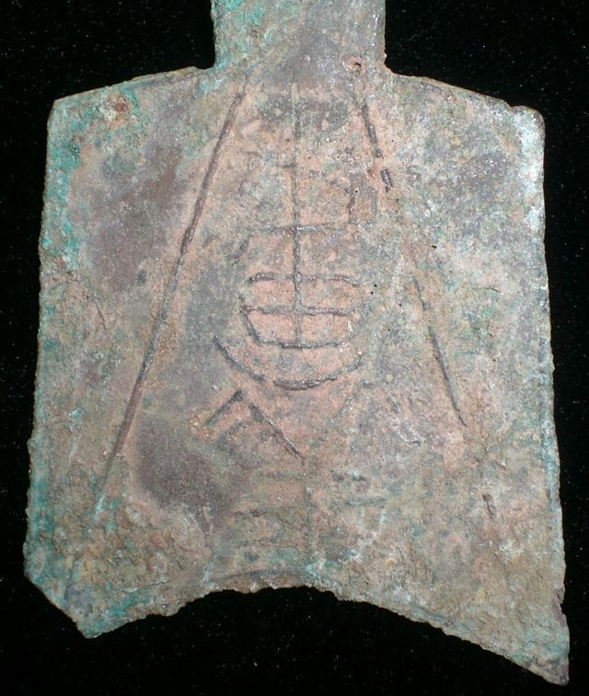

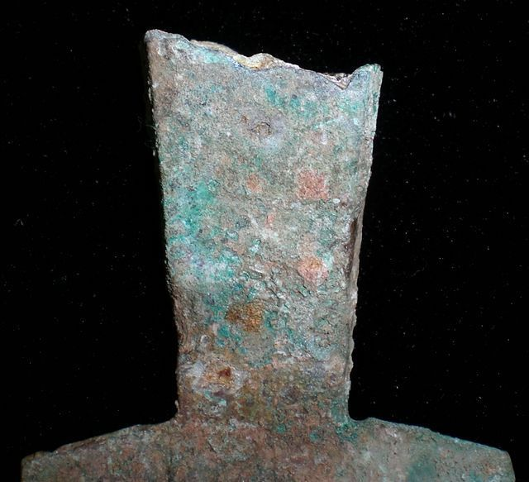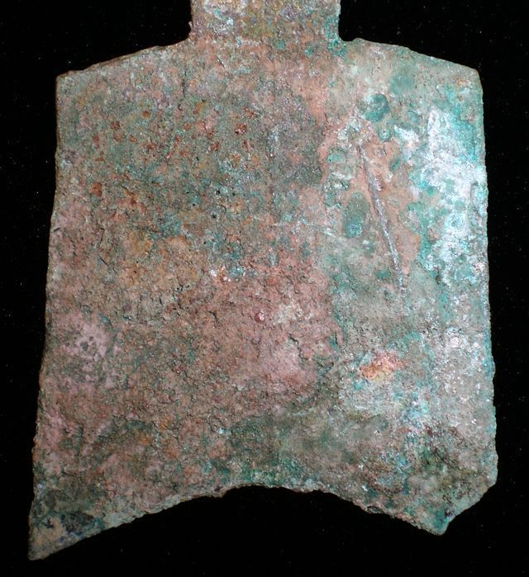 SHAPE \\* MERGEFORMAT 